An Explainable Multi-Source Spatiotemporal Machine Learning Approach for Traffic Accident Hotspot Prediction and Severity Classification in Sri Lanka
L.P.N.R.R. Pathirana  School of Computing and Engineering  National Institute of Business Management  Colombo, Sri Lanka  rahalnesara@gmail.com | Niranga Dharmarathne  School of Computing and Engineering  National Institute of Business Management  Colombo, Sri Lanka  niranga@nibm.lk

Abstract—Road traffic accidents (RTAs) pose a significant threat to human lives and the economy of Sri Lanka. Even though researchers have incorporated machine learning technologies to reduce the impacts of RTA, most of those implementations still rely on a single data source and consider hotspots as static components. Moreover, these implementations do not explain feature contribution to a prediction. Therefore, this paper presents an explainable, multi-source spatiotemporal machine learning approach for monthly accident hotspot prediction and severity classification, addressing the Sri Lankan context. Unlike many other developed countries, Sri Lanka lacks a proper data management system to handle accident-related data, resulting in the synthetic generation of 3688 historical accident records, which were then merged with weather data. Such data were then indexed into H3 hexagonal cells, where hotspot identification using a Poisson test with Benjamini–Hochberg false discovery rate control was implemented, creating a leakage-safe cell-month panel for model training. Logistic Regression, Random Forest, and XGBoost were then trained and evaluated to find the candidate model for each prediction task. Then SHAP was integrated into each candidate model, improving transparency and interpretability of the models. Finally, both prediction and their feature contributions were visualized through a developed prototype dashboard. However, this research is scoped within the Design Science Research (DSR) Λ contribution, ensuring no claims about real accident patterns. Rather, it should be interpreted as a reusable framework that is rigorously evaluated to demonstrate its feasibility.
Keywords—traffic accident hotspot prediction, severity classification, explainable AI, SHAP, spatiotemporal analysis, synthetic data, Sri Lanka

Introduction
Around 1.19 million people lose their lives due to RTAs, while a significant number suffer from serious injuries [1]. Accordingly, Sri Lanka also suffers from the same problem. For example, 2710 deaths were caused by road traffic accidents in 2025, which is more than 322 deaths compared to 2024 [2]. Moreover, fatalities caused by accidents cost around 0.25% of the country’s GDP, which is more than the government’s expenditure on the healthcare sector [3]. Even though the government has taken traditional measures such as laws, fines and awareness campaigns, the number of accidents still fluctuates each year [4].
However, advancements in machine learning technologies have enabled us with implementing proactive measures . Even though predicting accident hotspots using such technologies has been considered by local researchers, they still consist of 3 main gaps. One such gap is most of the local studies rely only on historical accident data, which limits model’s prediction performance. Also, accident risks vary across both time and space. But most of the local studies still consider them as static locations. Furthermore, ML models are considered as black box systems, which limits their transparency on safety critical domains. However, XAI technologies can be used to address these problems, yet such kind of technologies are underexplored in Sri Lankan context. Additionally, Sri Lanka also lacks a proper data management system that handles accident related data, resulting in accident information being maintained via physical books [5].
Accordingly, this study addresses such gaps through Design Science Research (DSR) [6] in the following way:
- By developing a leakage-safe, multi-source cell–month training panel that combines accident and weather data and indexing them to H3 hexagonal grids.
- By classifying hotspot H3 cells using a process based on a Poisson test with Benjamini–Hochberg correction.
- By comparing Logistic Regression (LR), Random Forest (RF) and XGBoost under rolling temporal validation to find a candidate model for hotspot prediction and severity classification tasks.
- By integrating SHAP explanations into prediction pipeline and visualization of prediction and SHAP outputs through a prototype dashboard.
According to Gregor and Hevner [6] there are 2 types of knowledge contribution in DSR projects. One is Λ (lambda) contribution which emphasize that a novel artefact can be designed, developed and rigorously evaluated to address a real world problem. The second type is an Ω (omega) contribution, which requires the relevant study to present real world insights through the developed artefact. Due to ML models used in this research being trained on synthetic data, the study is scoped within Λ contribution. Therefore, all the reported metrics must be interpreted as a demonstration of the framework and its evaluation criteria, rather than using them to claim ground truths about accidents in Sri Lankan context.

Related Work
Recent studies have incorporated supervised ML for accident hotspot prediction and severity classification tasks. A study by Santos et al. [7] has compared Decision Trees, RF, LR and Naïve Bayes to find a candidate model for hotspot prediction task in Portugal context. Accordingly, they found that RF performed best prediction task while using DBSCAN for identifying accident prone clusters. A study by Islam et al. [8] also found that RF performs best among RF, XGBoost and LR for severity classification while using Getis-Ord G_{i}* for hotspot analysis in Saudi Arabian context. Also, Amorim et al. [9], in their study on identifying hotspots on Brazilian highway have found that integrating contextual weather features can improve model performance significantly. Yan and Shen [10] also found similar performance gains after integrating contextual features for their RF severity prediction model.
Recent studies have explored using spatiotemporal modelling for hotspot prediction severity classification tasks. Ogungbire and Pulugurtha [11] explored sspatiotemporal analysis by combining space-time cube analysis with a XGBoost model to predict weather related crash risk in North Carolina region. Gedamu et al. [12] also showed that accident risk patterns vary across space and time. Furthermore, studies by Al-Omari et al. [13] and Aboulola [14] applied XAI technologies such as SHAP to their severity models to improve transparency and interpretability. Recent review on this matter also recommends integration of XAI as a priority for the domain [16].
When to comes to Sri Lankan context, Jayamanna and Kalansooriya [17] developed a mobile application for hotspot prediction and severity classification task using RTA data collected from Mount Lavinia police records and found that XGBoost and RF perform best for each task. However, Jayamanna and Kalansooriya [17] still relied on a single data source and didn’t incorporate spatiotemporal modelling and XAI technologies for their study.

Methodology

Research Design and Data Sources
The study is conducted according to the DSR approach, which consists of steps such as problem identification, solution design, development and evaluation [6], under a pragmatist philosophy. Accordingly, 3 main data sources were used for this study. The first is anonymized historical police accident records collected from Slave Island police station, which were used to understand the structure of historical accident records. However, due to such data records still being maintained in physical books, only a very limited number of data records were able to be collected. Therefore, 3688 data records covering the time period of 2022-2023 and the Colombo Municipal Area (CMA) were synthetically generated, which is also the second data source. Accordingly, statistical distributions obtained from 5 local empirical sources were used to generate such data (Table I). However, as independent sampling does not capture relationship between variables, 3 conditional rules with a combined probability capped at 50% were introduced to shift severity one level upward: R1, night-time on a main road (+10%); R2, motorcycle or pedestrian involvement (+15%); and R3, alcohol as the cause (+20%). Finally, the weather data that covers the same period were obtained from the Visual Crossing API [18] and merged into the synthetic dataset.
- Empirical Sources Used to Anchor the Synthetic Data
ID | Source | Attribute anchored
A1 | Department of Census and Statistics [19] | Accidents per police division, 2022–2023
A2 | Sri Lanka Police traffic reports [20] | National severity mix
A3 | Thilakarathna et al. [21] | Time and cause, fatal accidents
A4 | Jayasinghe et al. [22] | Time and cause, non-fatal accidents
A5 | OpenStreetMap via OSMnx [23] | Street names per division

Not all empirical sources were specific to Colombo Area. For example, severity mix distribution was obtained from a national source and the empirical sources used to extract the time and cause distribution belong to Ragama and Matara areas. However, such limitations are accepted within the DSR lambda scope as the goal is to output a framework that is rigorously evaluated within the Sri Lankan context rather than to reproduce exact Colombo accident patterns.

Spatial Indexing and Hotspot Labelling
Google Maps API was used to geocode accident locations and were then indexed into Uber's H3 hexagonal grid [24]. The reason for choosing hexagons over other shapes is that it gives six equidistant edge neighbors for each cells, while also avoiding the corner-adjacency problem of square grids. Also, Resolution 8 (about 0.737 km² per cell) was chosen for H3 cells due to limited number of records, which cause higher resolution to create sparse cells. Accordingly, 79 cells and a cell-month panel consisting of 1896 were created (79 cells × 24 months).
Hotspots are defined for each cell and each month. For target month T, the mean count across all cells is considered as the expected count under complete spatial randomness. This includes cells with no accidents:
λ_{T} = (1/|C|) Σ_{c∈C} n_{c,T} (1)
In here, C is the set of 79 cells and n_{c,T} is the number of accidents in cell c during month T. Each cell's one-sided p-value is then calculated as follows.
p_{c,T} = P(X ≥ n_{c,T}), X ~ Poisson(λ_{T}) (2)
Also, to control false positives across the 79 tests of each month, the Benjamini–Hochberg procedure [25] is applied within the month: with p-values ranked in ascending order, the k-th is significant if
p_{(k)} ≤ kα/m (3)
with m = 79 and α = 0.05. A cell is labelled a hotspot for month T when its adjusted p-value is below 0.05, that is, when its count is significantly higher than the citywide monthly average. The reason for using this method instead of a fixed percentile threshold is because that it gives every label a statistical basis. Accordingly, this process produced 108 hotspot cell–months which is around 5.7% of the total records.

Leakage-Safe Spatiotemporal Features
For each cell month row (c, T), features use only information available before the start day of the month s_{T.} Additionally, rolling accident count of same cell and its six first-order neighbors N(c) are calculated over 30, 90 and 180 days’ time window w:
S_{c,T}(w) = |{ j : c_{j} = c, s_{T} − w ≤ t_{j} < s_{T} }| (4)
where t_{j} is the date of accident j; the neighbor count replaces c_{j} = c with c_{j} ∈ N(c). The panel also includes 180-day shares of peak-hour, night-time and motorcycle accidents, the previous month's weather (precipitation, humidity, visibility, cloud cover and share of rainy days), calendar terms, cell coordinates and police division, giving 36 features. Also, when it comes to severity, the dominant severity class (Fatal, Serious, Minor or Damage-only) of each cell month with at least one accident was labelled as its severity.

Model Training and Evaluation
Both prediction tasks were trained using LR, RF and XGBoost with class imbalance addressed using balanced class weights for LR and RF and balanced sample weights for XGBoost. The cell-month training panel followed a temporal split where, data up to August 2023 were used for training, and September–December 2023 were held out as the test set. When it comes to training split, rolling temporal validation with six two-month folds was used to select the model and fine tune the hotspot threshold, while also configuring the number of XGBoost rounds. Also, preprocessing techniques were only applied to the training folds. Once, relevant models were trained and evaluated, candidate model for hotspot was chosen based on the pooled validation F1 and severity classifier’s candidate based on the mean validation macro-F1. Furthermore, synthetic data were separately evaluated using chi-square goodness-of-fit tests against each empirical source (α = 0.05) and chi-square independence tests for rules R1–R3.
- Model Configurations
Model | Main settings (both tasks unless stated)
LR | Standardised features; balanced class weights; liblinear solver (hotspot), lbfgs (severity)
RF | 300 trees; maximum depth 8; minimum 5 samples per leaf; √p features per split; balanced class weights
XGBoost | Learning rate 0.05; maximum depth 5; subsample 0.8; positive-class weight (hotspot) or balanced sample weights (severity); rounds set from rolling validation

Evaluation Strategy and Scope of Claims
Evaluation strategy followed an ex post strategy within the FEDS framework [26]. As the study follows a DSR lambda contribution approach, such evaluations were conducted in a controlled, benchmark-style environments rather than with live data or real users, which consists of 2 layers. Accordingly, synthetic data validation layer checks whether the generated synthetic data adhere to the statistical distribution of their empirical sources and framework validation layer checks whether each component works and performs as expected. Accordingly, this layer includes model metrics on the temporal test window, seven scripted functional test cases derived from the functional requirements, response times measured over 20 sequential requests per API endpoint, and a heuristic usability review of the dashboard based on a reduced set of Nielsen's heuristics plus an explanation-specific check. However, none of these layers claims any ground truths related to RTAs in CMA. Its rather a demonstration of pipeline’s ability to learn and explain the patterns in its training data.

Explainability and Delivery
SHAP TreeExplainer [14] was integrated into each candidate model to explain the global feature rankings and the top four feature contribution to each prediction, improving transparency and interpretability of the framework . Finally both predictions and their XAI explanation were visualized through a prototype dashboard. Accordingly, the system follows a 5-layer architecture from data collection to delivery layer and it is visualized in the below Fig. 1.
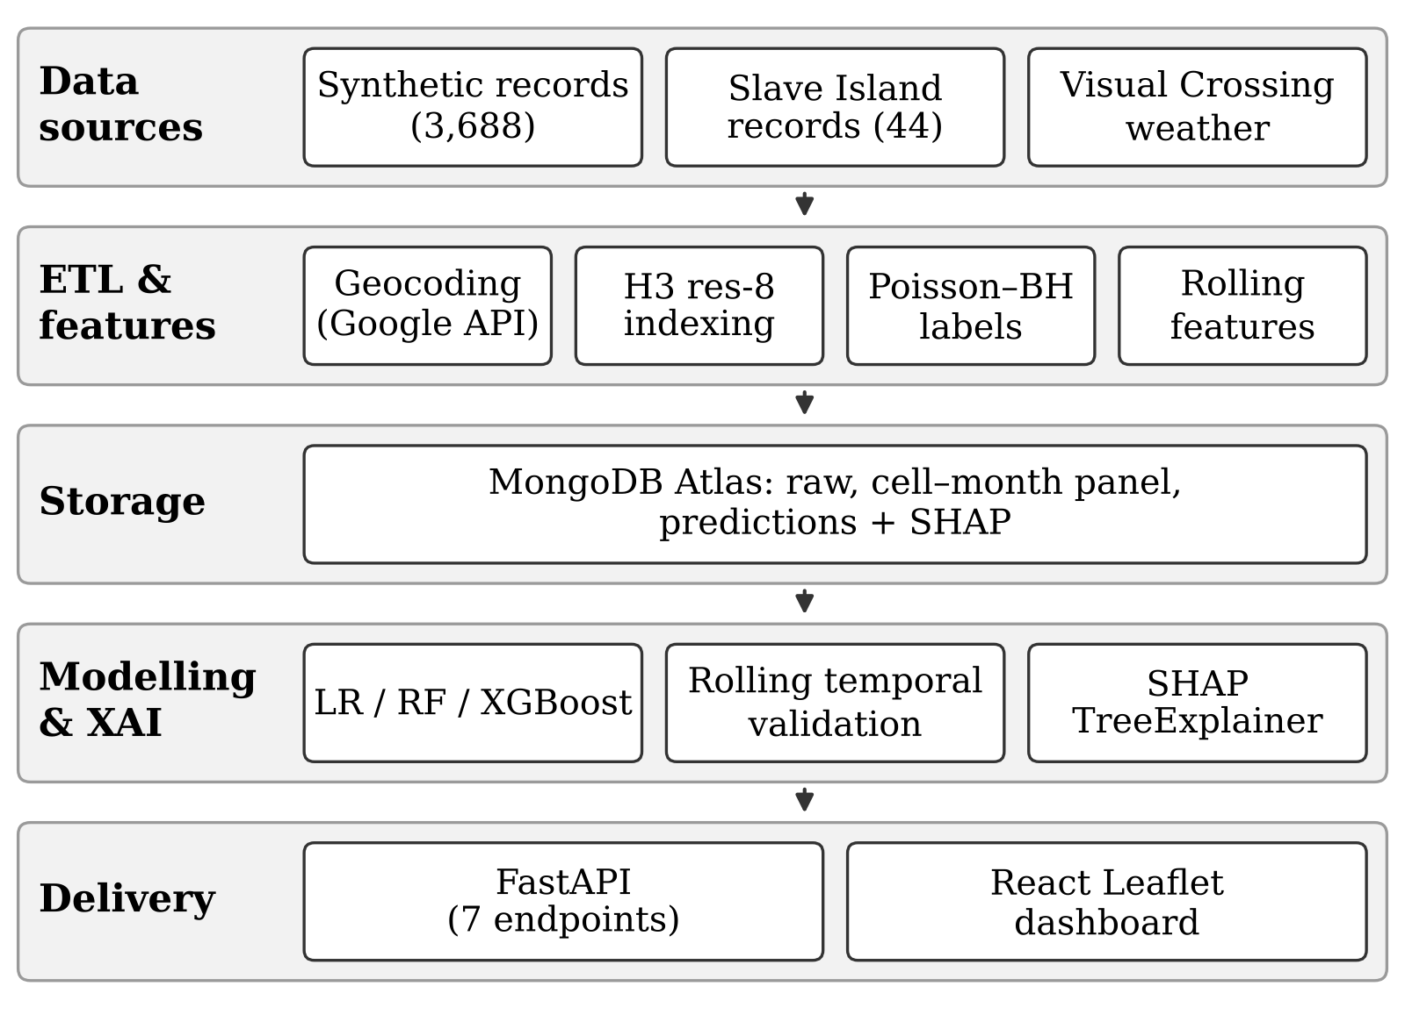
- Five-layer architecture of the proposed approach.

Results
The results only demonstrate how the pipeline work on source-anchored synthetic data within Λ scope. Therefore, they must not be interpreted as real world performance of models within CMA context.

Synthetic Data Fidelity
Eight of the nine tested attributes showed no significant difference from their relevant empirical sources (Table III). The only deviation is severity, which is intended due to introduced conditional rules. (R1-R3). The Table III also shows how severity still matched to their empirical source before the rules.
- Chi-Square Goodness-of-Fit of the Synthetic Data
Attribute (anchor) | χ² (df) | p-value
Severity, before rules (A2) | 3.93 (3) | 0.270
Severity, after rules (A2) | 97.71 (3) | < 0.001*
Severity, Slave Island (A2) | 7.67 (3) | 0.053
Time of day, fatal (A3) | 4.47 (3) | 0.215
Time of day, non-fatal (A4) | 3.67 (4) | 0.453
Cause, fatal (A3) | 11.18 (8) | 0.192
Cause, non-fatal (A4) | 5.03 (8) | 0.755
Collision type (A3) | 2.33 (3) | 0.507
Driver age group (A3) | 9.14 (6) | 0.166
*Intended divergence caused by conditional rules R1–R3.

Hotspot Prediction
RF was selected as the candidate model for hotspot prediction task with the highest pooled validation F1 (0.495). Additionally, it also achieved the highest ROC-AUC (0.957) and recall (0.933) on test window, identifying 14 out of 15 hotspots with 28 false positives (Table IV). However, it only achieved a moderate F1-Score of 0.491 and that is because only 4.7% of the test rows are labelled as hotspots. Accordingly, this shows labelling, feature and validation design works end to end with synthetic data. However they don’t claim that those models can predict accidents occur in CMA within Λ scope.
- Hotspot Prediction on the Temporal Test Window
Metric | LR | RF* | XGBoost
Validation F1 (pooled) | 0.370 | 0.495 | 0.481
Test F1 | 0.522 | 0.491 | 0.429
Test ROC-AUC | 0.940 | 0.957 | 0.946
Test average precision | 0.478 | 0.478 | 0.382
Test precision | 0.387 | 0.333 | 0.293
Test recall | 0.800 | 0.933 | 0.800
Decision threshold | 0.83 | 0.62 | 0.23
*Selected model. Test window: September–December 2023, 316 cell–months, 15 hotspots.
Fig. 2 shows the ROC and precision–recall curves of the three models and it is clear that all 3 models rank cell-month well above the random baseline. Also, their ROC lines lie closely as well. Moreover, precision-recall curves show that both LR and RF performed better compared to XGBoost achieving an average precision score of 0.478 compared to XGBoost’s 0.382. Accordingly, the selected RF model correctly identified 14 out of 15 actual hotspots, while classifying 28 non-hotspot cell-months as hotspot cells.

Severity Classification
According to Table V severity classification is much weaker compared to hotspot prediction. XGBoost was selected as the candidate model based on its validation macro-F1 of 0.258. Additionally, the model achieved a low accuracy of 0.328, highlighting that it struggled to identify patterns related to accident severity in the given dataset. Accordingly, these weak performance highlights limitations of severity classifier of the proposed framework, which may be caused by synthetic data.
- Severity Classification on the Temporal Test Window
Metric | LR | RF | XGBoost*
Validation macro-F1 | 0.193 | 0.232 | 0.258
Test macro-F1 | 0.195 | 0.185 | 0.236
Test accuracy | 0.272 | 0.236 | 0.328
F1, Fatal | 0.107 | 0.063 | 0.063
F1, Serious | 0.051 | 0.231 | 0.362
F1, Minor | 0.457 | 0.362 | 0.444
F1, Damage-only | 0.163 | 0.085 | 0.074
*Selected model. Test window: 195 cell–months with at least one accident.
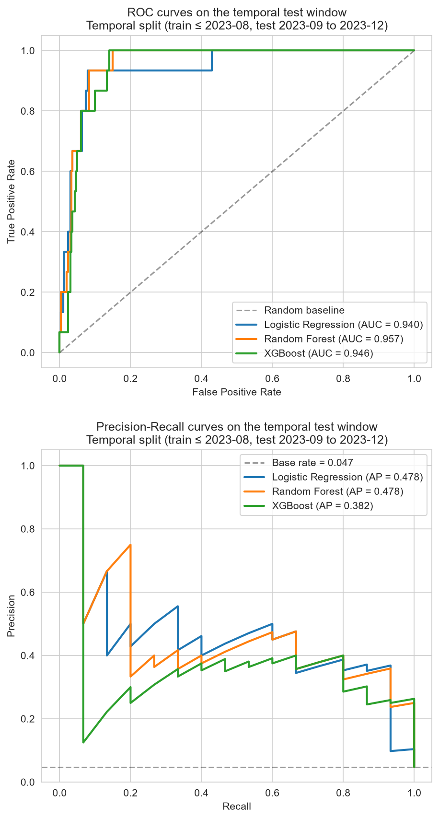
- ROC (top) and precision–recall (bottom) curves of the hotspot classifiers on the temporal test window.

Explainability and System Evaluation
Fig. 3 shows the SHAP summary for the RF hotspot model on the test window. Accordingly, accident counts in the same cell over the previous 180, 90 and 30 days had largest impact for a prediction. It was then followed by features such as cell location and neighboring-cell counts, temporal shares and month. However, weather features contributed least to a prediction which may be because of the synthetic data not having a real relationship with weather data obtained from Visual Crossing API [18]. These limitations are addressed within Λ scope as the proposed framework only demonstrate the technical feasibility rather than claiming patterns related to real word accident causations.
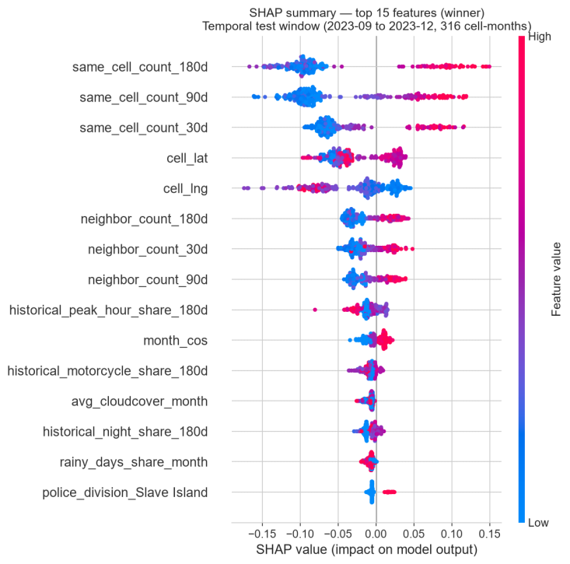
- SHAP summary of the Random Forest hotspot model on the test window (September–December 2023).
Fig. 4 shows a prototype dashboard with predicted hotspot for November 2023. Accordingly, each H3 cell is colored based on the predicted hotspot status and severity level. A user can select a cell to view more details such as hotspot probability, the observed outcome for that month and the four SHAP contributions behind each hotspot and severity predictions.
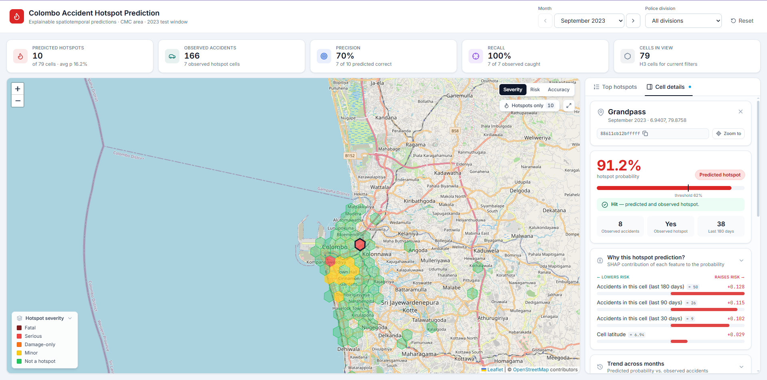
- Dashboard view for November 2023, showing predicted hotspots and the SHAP explanation for a selected cell.
- Response Times of the Deployed Prototype
Request | Mean (ms) | 95th pct. (ms)
GET /cells (all 79 cells) | 717 | 784
GET /cells/{h3_cell} | 498 | 514
GET /hotspots | 711 | 760
GET /severity/{h3_cell} | 506 | 548
GET /xai/{h3_cell} | 503 | 550
Dashboard load, repeat visit | 1,758 | 1,824
Dashboard load, first visit | 2,815 | –
20 sequential requests per endpoint; all requests filtered by month.
Seven functional test cases designed to test the framework passed covering the ETL pipeline, synthetic data generation, panel construction, hotspot labelling, model training, SHAP generation and delivery through the REST API and dashboard. Also, Table VI reports response times for the prototype dashboard which is deployed on Vercel with MongoDB Atlas. However, such performance doesn’t reflect real word performance as the dashboard itself is prototype developed to demonstrate the framework. Moreover, in the heuristic review, three heuristics passed (visibility of system status, user control and freedom, and the added check that SHAP direction matches the contribution sign) and four were partially achieved. This is mainly because of the visualization of the SHAP explanations were still presented in a technical form in the prototype dashboard.

Interpretation of Results
The results of the framework must be interpreted within the defined DSR Λ scope. Accordingly, high ROC-AUC and recall in the hotspot classifier confirm that the candidate model can rank risky accidents very well, which shows that an approach similar to this can be adapted for operationalizing tasks like prioritizing patrols each month. Also, the temporal test outputs can be considered genuine future predictions because the month-by-month Poisson labels and pre-cutoff features prevent as they prevent the candidate model from memorizing which models were historically dangerous
Also, according to the results, the performance of the severity classifier is weak. This is mainly because of the limitations of the current synthetic dataset, as it contains features mostly related to accident volume and exposure rather than features that determine the severity of a RTA such as road type, junction layout, lighting, or speed limits. Moreover, the usage of synthetic data itself may have resulted in such low performance, emphasizing the need for real world RTA data along with additional infrastructure related features.

Comparison with Existing Studies
Table VII compares the proposed approach with the studies reviewed in Section II. Even though, previous studies cover some of these features, none combine multi-source data, spatiotemporal features, SHAP for both tasks and leakage-safe validation in a one unified framework that addresses Sri Lankan context.
- Comparison with Existing Studies
Feature | [7] | [8] | [9] | [17] | [13] | [11] | Ours
Sri Lankan context | × | × | × | ✓ | × | × | ✓
Weather data | × | × | ✓ | × | × | ✓ | ✓
Spatiotemporal features | ~ | ~ | × | × | × | ✓ | ✓
SHAP explanations | × | × | × | × | ~ | × | ✓
Hotspot and severity | × | ✓ | × | ✓ | × | × | ✓
Leakage-safe validation | × | × | × | × | × | × | ✓
Synthetic data checks | × | × | × | × | × | × | ✓
Dashboard or API | × | × | × | ✓ | × | × | ✓
✓ = present; ~ = partial; × = absent. [13] applies SHAP to severity only; [17] is a mobile application without explanations.

Reusable Design Knowledge and Implications
As a Λ contribution, the study provides reusable design decisions that can be carried over to real data:
- Classification of hotspots based on statistical test against a citywide expectation via Poisson Distribution and false discovery rate control
- Use of features available before the month that is supposed to predict to prevent data leakage
- Use of rolling validation to select candidate model and fine tune thresholds, while also keeping test window untouched under a temporal split
- Use of SHAP to explain each prediction, which allows users to understand what features contributed to the prediction.
Accordingly, the study shows that designed pipeline can assist relevant authorities such as traffic police on decision making process by identifying list of potential hotspot cells for the coming month with the reason (feature contribution) for each prediction. However, the framework must undergo retraining using real world data before the real word deployment.
Furthermore, the main limitation of this study was the data scarcity, which led to generation of synthetic data based on the statistical distribution obtained from five published local empirical sources. Also, prototype version is limited to CMA.

Conclusion
This paper presented an explainable, multi-source spatiotemporal approach for monthly accident hotspot prediction and severity classification in Sri Lanka, addressing the reliance on single data sources, the lack of spatiotemporal modelling and the absence of explainability in local work. Using source-anchored synthetic data, statistically defined monthly hotspots and leakage-safe features, RF ranked hotspot cells with a ROC-AUC of 0.957, while severity remained close to chance, and SHAP explanations were delivered for every prediction. Consistent with its Λ positioning, the paper contributes a reusable, rigorously evaluated methodology; its numerical results make no claims about road traffic accidents in the CMA, and real-world (Ω) value can only be established by applying the framework to official records. Future work should retrain the pipeline on digitised police records with a full train-on-synthetic, test-on-real evaluation, add road infrastructure features, extend coverage beyond Colombo, and present SHAP output as plain-language guidance for traffic authorities.

Acknowledgment
The authors thank the Traffic Division of Slave Island Police Station for access to accident records.

References
- World Health Organization, Global Status Report on Road Safety 2023. Geneva, Switzerland: WHO, 2023.
- Daily Mirror, “Road accident deaths rise in 2025,” dailymirror.lk, 2026. [Online]. Available: https://www.dailymirror.lk/breaking-news/Road-accident-deaths-rise-in-2025/108-329246
- T. L. Gunaruwan and P. C. J. Nayanalochana, “Economic cost of human fatalities due to road traffic accidents in Sri Lanka: An estimation based on the human capital approach,” J. South Asian Logist. Transp., vol. 3, no. 1, pp. 39–57, 2023, doi: 10.4038/jsalt.v3i1.59.
- T. L. S. S. Siritunga, “Road traffic crashes in Sri Lanka: An epidemic that demands multisectoral public-health mobilization,” J. Coll. Community Physicians Sri Lanka, vol. 31, no. 4, pp. 116–121, 2025, doi: 10.4038/jccpsl.v31i4.8902.
- N. C. Selvaratnam, N. D. Selvaratnam, P. Lanter, S. D. Dharmaratne, and P. C. Acker, “Evaluating Sri Lanka’s road traffic crash and injury research: A systematic review focusing on data sources and methodological approaches,” Eur. J. Public Health Stud., vol. 8, no. 2, 2025, doi: 10.46827/ejphs.v8i2.214.
- S. Gregor and A. R. Hevner, “Positioning and presenting design science research for maximum impact,” MIS Q., vol. 37, no. 2, pp. 337–355, 2013, doi: 10.25300/MISQ/2013/37.2.01.
- D. Santos, J. Saias, P. Quaresma, and V. B. Nogueira, “Machine learning approaches to traffic accident analysis and hotspot prediction,” Computers, vol. 10, no. 12, p. 157, 2021, doi: 10.3390/computers10120157.
- Md. K. Islam, I. Reza, U. Gazder, R. Akter, M. Arifuzzaman, and M. M. Rahman, “Predicting road crash severity using classifier models and crash hotspots,” Appl. Sci., vol. 12, no. 22, p. 11354, 2022, doi: 10.3390/app122211354.
- B. de S. P. Amorim, A. A. Firmino, C. de S. Baptista, G. Braz Júnior, A. C. de Paiva, and F. E. de Almeida Júnior, “A machine learning approach for classifying road accident hotspots,” ISPRS Int. J. Geo-Inf., vol. 12, no. 6, p. 227, 2023, doi: 10.3390/ijgi12060227.
- M. Yan and Y. Shen, “Traffic accident severity prediction based on random forest,” Sustainability, vol. 14, no. 3, p. 1729, 2022, doi: 10.3390/su14031729.
- A. Ogungbire and S. S. Pulugurtha, “Spatiotemporal risk mapping of statewide weather-related traffic crashes: A machine learning approach,” Mach. Learn. Appl., p. 100642, 2025, doi: 10.1016/j.mlwa.2025.100642.
- W. T. Gedamu, U. P. Wiedenbeck, and B. T. Wodajo, “Spatio-temporal analysis of road traffic crashes by severity,” Transp. Eng., vol. 20, p. 100327, 2025, doi: 10.1016/j.treng.2025.100327.
- A. Al-Omari, M. Alsaleh, and N. Shatnawi, “Spatial-temporal analysis and severity prediction of traffic accidents,” Eng. Sci., 2025, doi: 10.30919/es1472.
- O. I. Aboulola, “Improving traffic accident severity prediction using MobileNet transfer learning model and SHAP XAI technique,” PLoS ONE, vol. 19, no. 4, p. e0300640, 2024, doi: 10.1371/journal.pone.0300640.
- S. M. Lundberg and S.-I. Lee, “A unified approach to interpreting model predictions,” in Proc. Adv. Neural Inf. Process. Syst. (NeurIPS), 2017, pp. 4765–4774.
- N. Hamdan and T. Sipos, “Advancements in machine learning for traffic accident severity prediction: A comprehensive review,” Period. Polytech. Transp. Eng., vol. 53, no. 3, pp. 347–355, 2025, doi: 10.3311/pptr.40369.
- J. M. C. T. Jayamanna and P. Kalansooriya, “Development of an intelligent road safety mobile navigation application using machine learning for real-time accident hotspot and severity prediction: A case study in Sri Lanka,” in Proc. 5th Int. Conf. Adv. Highway Eng. Transp. Syst. (ICAHETS), 2024, pp. 17–35, doi: 10.31705/ICAHETS.2024.8.
- Department of Census and Statistics, Statistical Abstract 2024, ch. 7. Colombo, Sri Lanka, 2024. [Online]. Available: https://www.statistics.gov.lk/abstract2024/chapter7
- Sri Lanka Police, “2025 traffic reports,” 2025. [Online]. Available: https://www.police.lk/?p=21248
- W. G. S. R. Thilakarathna, M. T. K. L. Thudugala, W. A. C. J. Hangilipola, S. Perera, and P. Paranitharan, “Road traffic accidents in Sri Lanka: A retrospective analysis and artificial intelligence-based solutions for prevention,” Sri Lanka J. Forensic Med. Sci. Law, vol. 16, no. 1, pp. 22–29, 2025, doi: 10.4038/sljfmsl.v16i1.7991.
- B. C. Jayasinghe, N. C. Withanage, and P. K. Mishra, “Evaluating geographical variations of road traffic accidents in Matara, Sri Lanka: A geospatial perspective to policy decisions,” Rev. Int. Géomatique, vol. 34, no. 1, pp. 707–729, 2025, doi: 10.32604/rig.2025.067395.
- G. Boeing, “Modeling and analyzing urban networks and amenities with OSMnx,” Geogr. Anal., 2025, doi: 10.1111/gean.70009.
- Visual Crossing, “Weather data and weather API.” [Online]. Available: https://www.visualcrossing.com/
- Uber Technologies, “H3: Uber’s hexagonal hierarchical spatial index.” [Online]. Available: https://www.uber.com/blog/h3/
- Y. Benjamini and Y. Hochberg, “Controlling the false discovery rate: A practical and powerful approach to multiple testing,” J. R. Stat. Soc. Ser. B, vol. 57, no. 1, pp. 289–300, 1995.
- J. Venable, J. Pries-Heje, and R. Baskerville, “FEDS: A framework for evaluation in design science research,” Eur. J. Inf. Syst., vol. 25, no. 1, pp. 77–89, 2016, doi: 10.1057/ejis.2014.36.

